

Tutorial for SEPAL workshop

BOGOR, 19-22 February 2019

Contact: [remi.dannunzio@fao.org](mailto:remi.dannunzio@fao.org) & [erik.lindquist@fao.org](mailto:erik.lindquist@fao.org)

## Background and Context

Peatlands cover only 3% of global land area but store nearly 30% of the world’s soil carbon and may contain twice as much carbon as the world’s forests. Peatlands are found in many countries and have recently come under increased threats including from overexploitation. Peat-based related greenhouse gas emissions are significant and are estimated to cause approximately 10% of total emissions from the Agriculture, Forestry and other Land Use sectors (AFOLU).

In her first Nationally Determined Contribution (NDC), Indonesia has set an ambitious target: “Peat restoration achieves 90% survival rate and the area of peat restoration reaches 2 Mha by 2030”.

To be able to realize the peatland restoration target efficiently and demonstrate its impacts, it is important to develop a robust and transparent monitoring system for peatlands. There are relatively few experiences of successful peatland restoration, and restoration approaches are being further developed rapidly around the globe. In this context, the National Peatland Restoration Agency (BRG) is engaged in a collaborative project with national and international partners to develop the Peatland Restoration Information Monitoring System (PRIMS) to provide alerts in case of major lowering of water tables and support Indonesia’s targets for tracking the progress of revegetation and developing further restoration approaches.

The purpose of the development of PRIMS is to communicate results and outcomes and also to encourage positive momentum, to inspire and allow for transferable resolve, to guide and support implementation of restorations and provide feedback including continuous and collective learning for adaptive management.

In parallel, FAO has developed a System for Earth Observation Data Access, Processing and Analysis for Land Monitoring (SEPAL), which helps countries’ access and process satellite data. SEPAL is a big-data processing platform that combines super-computing power, open-source geospatial data processing software and modern geospatial data infrastructures like Google’s Earth Engine. SEPAL overcomes barriers of poor internet connections and low computing power or storage space on local computers and can also connect to and use data and outputs from FAO’s free and open-source software tools Open FORIS.

The SEPAL platform is open source, free of charge and can be accessed at <https://sepal.io>

This project will focus initially on the development of a peatlands monitoring system with global application within the SEPAL platform, and the development of calculations chains to monitor restoration (rewetting and revegetation), degradation, and deforestation. It will develop an innovative monitoring system for peatlands specifically for Indonesia and provide related technical assistance and capacity building for its operationalization in Indonesia. The peatland monitoring system building on the SEPAL platform will provide a new and innovative tool to advance peatlands monitoring in the most cost-effective, rapid, yet robust manner.

## Modular structure of PRIMS-SEPAL tools

Preliminary work has been undertaken by FAO’s technical team to draft the modules that will power the PRIMS.

The tools have been designed to provide relevant data under the following assumptions:

- Peatland conditions can be estimated through biophysical parameters detectable from remotely-sensed data.

- Vegetation changes can be indicative of some kinds of condition improvements / degradation.

- Soil moisture is an important indicator of peatland condition.

- Physical location of canals and management activities are important indicators of peatland condition.

The tools enable to monitor peatland condition and specifically:

1/ Existence and condition of dams and canals

2/ Analysis of field-based groundwater level and soil moisture

3/ Analysis of remote sensing data for vegetation change

4/ Analysis of remote sensing data for soil moisture

5/ Analysis of remote sensing data for land subsidence

REQUIREMENTS  
All necessary data for the completion of this tutorial is available at <https://github.com/openforis/prims.git>

Background information on the OpenForis initiative [www.openforis.org](http://www.openforis.org/" \t "/home/dannunzio/Documentsx/_blank)

You can request Access to SEPAL with the following

1/ have-open a GMAIL account (in order to access Google Earth Engine functionality)

2/ get the account registered and white listed in Google Earth Engine [https://earthengine.google.com/signup/](https://earthengine.google.com/signup/" \t "/home/dannunzio/Documentsx/_blank)

3/ open an account in SEPAL [https://tinyurl.com/sepal-access](https://tinyurl.com/sepal-access" \t "/home/dannunzio/Documentsx/_blank)

CONTENT OF THE TUTORIAL

[1. HANDS-ON WITH CEO 5](#_Toc1350237111)

[2. HANDS-ON WITH CEO 5](#_Toc444489052)

[2. Generate Data 6](#_Toc1649147747)

[2.1 Generate satellite imagery Time Series for an index 6](#_Toc799457808)

[2.2 Run BFAST 7](#_Toc1151618179)

[3. R training 11](#_Toc2011524946)

[4. Generate visual snippets of imagery to support change validation 14](#_Toc1043242106)

1. Hands-on with CEO

Go to <collect.earth>

Select Login/Register. First time users need to provide a valid email address and a password.

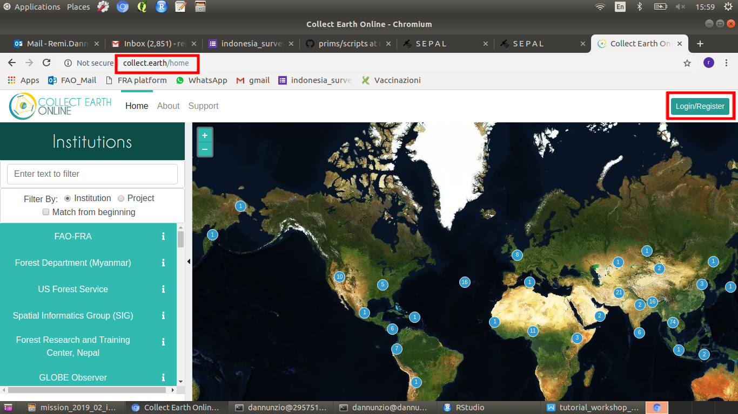

In the search bar, type “PRIMS” & select the “dams\_check” project

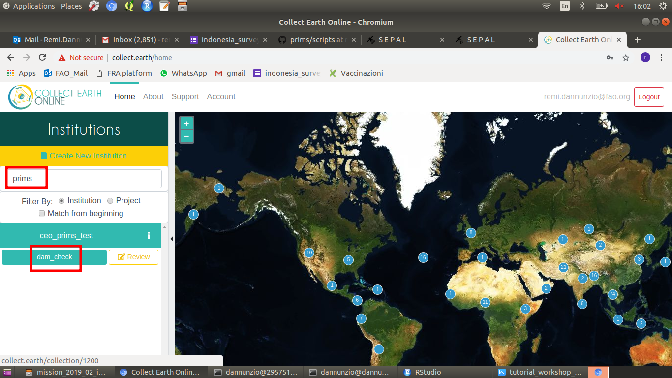

Zoom into the AOI and select one group of points.

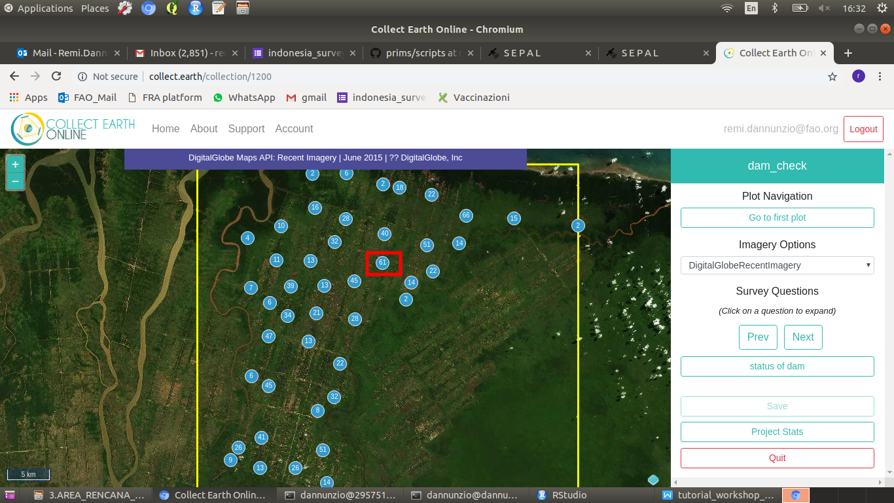

Zoom until you find a point with imagery and select it (click so that it shows in blue). Click on “Status of dam” and choose among the possible answers. Save.

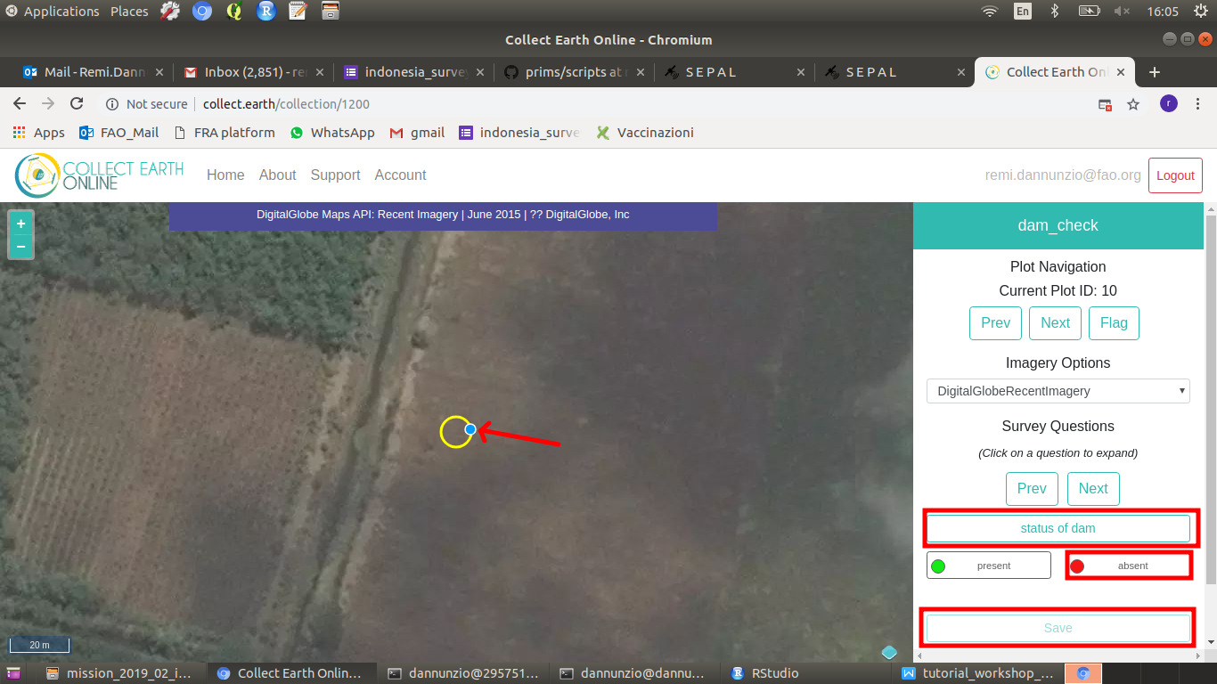

When you have finised go to Quit. You can start at any other moment, your collection is saved.

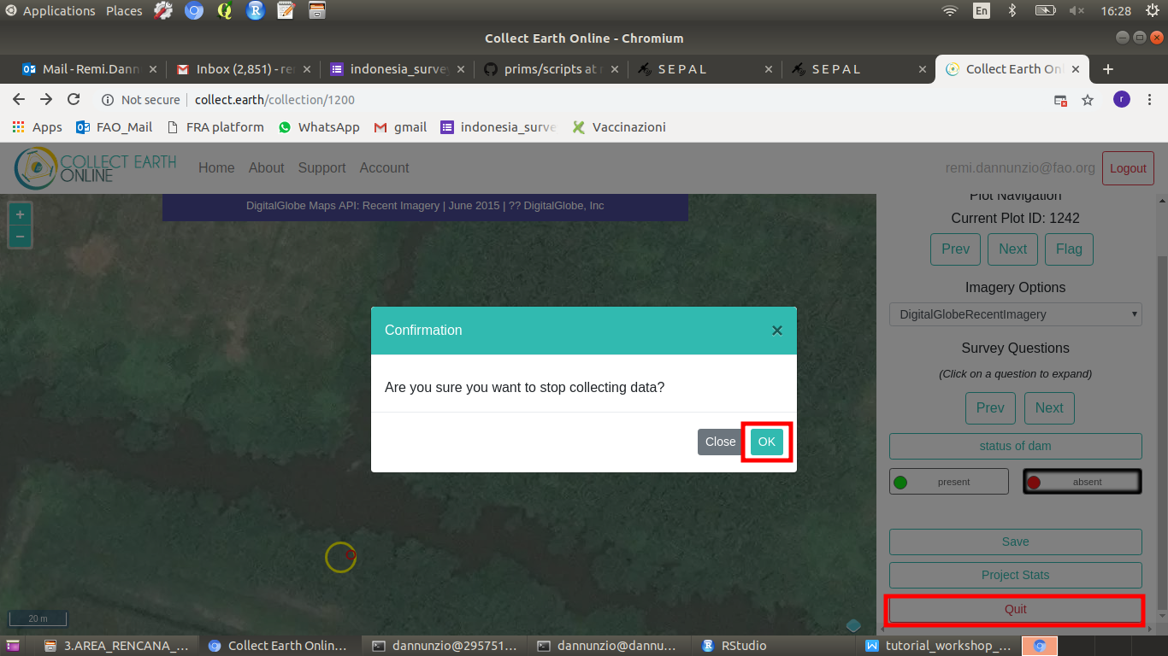

Data results are available under Project Review / Download Plot or Sample data

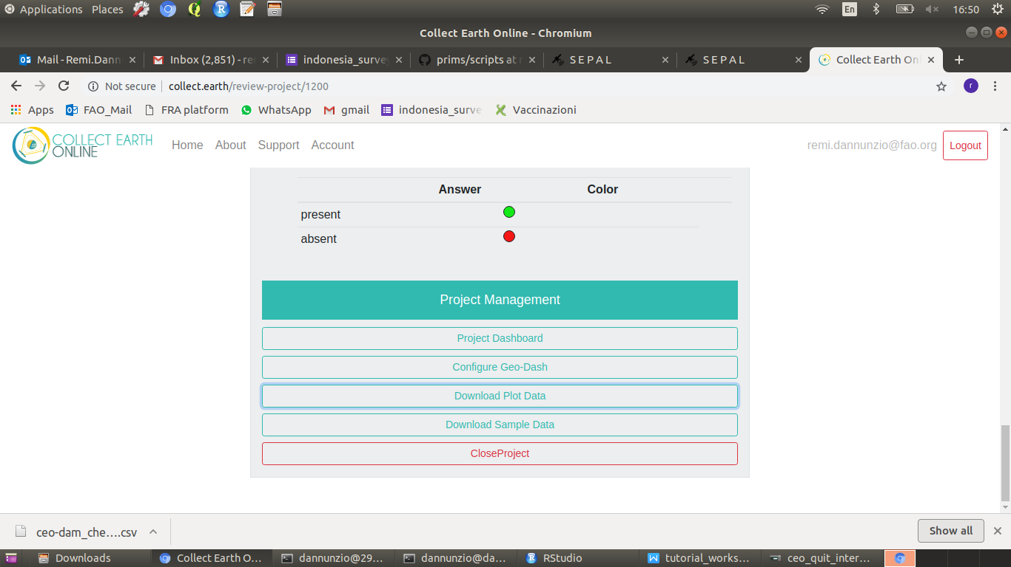

THe results come as a CSV file that you can further analyze in excel or use as an input in your GIS environment

2. CUSTOMIZE A CEO PROJECT

Go to <https://sepal.io>

Open the terminal and start a #4 instance (type 4 and ENTER)

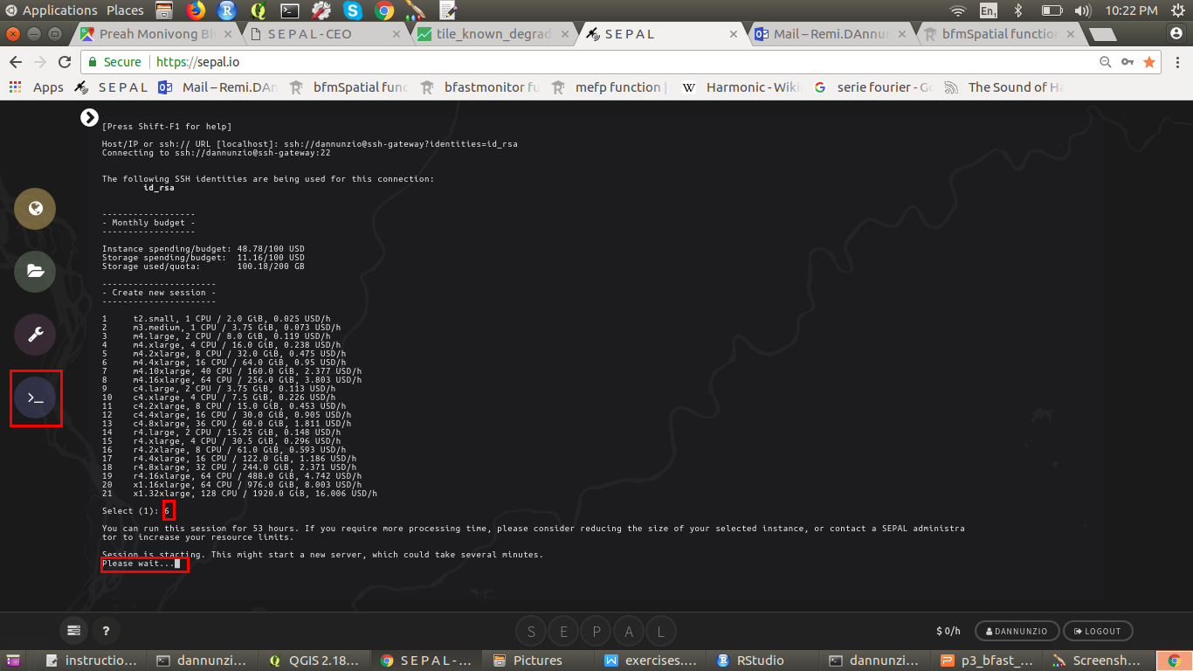

Once the instance is started and you get the prompt back (>), clone the PRIMS repository

git clone https://github.com/openforis/prism

When the repository is cloned, go to Process and start RStudio

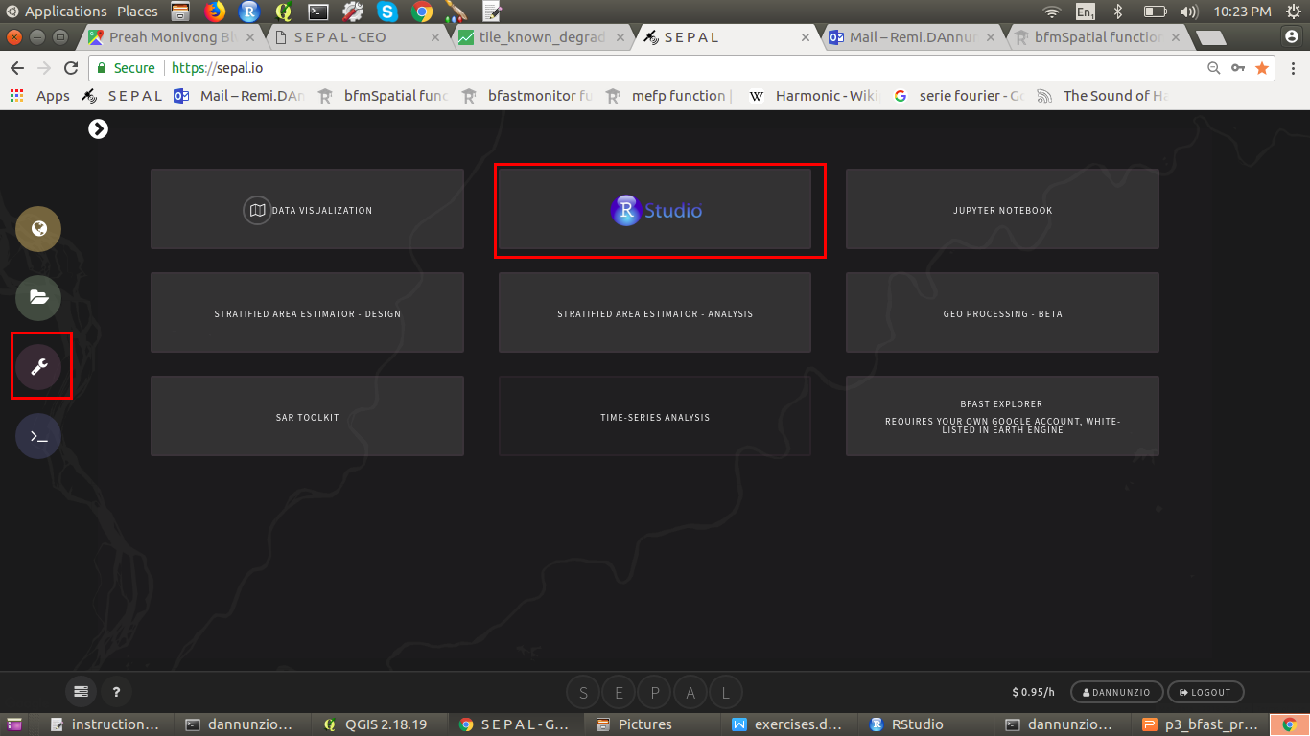

Load the scripts (under “~/prism/scripts/”)from the workshop folder.

You can either run a script as a whole (source) or line by line (run).

The keybaord shortcut for RUN is CTRL+ENTER

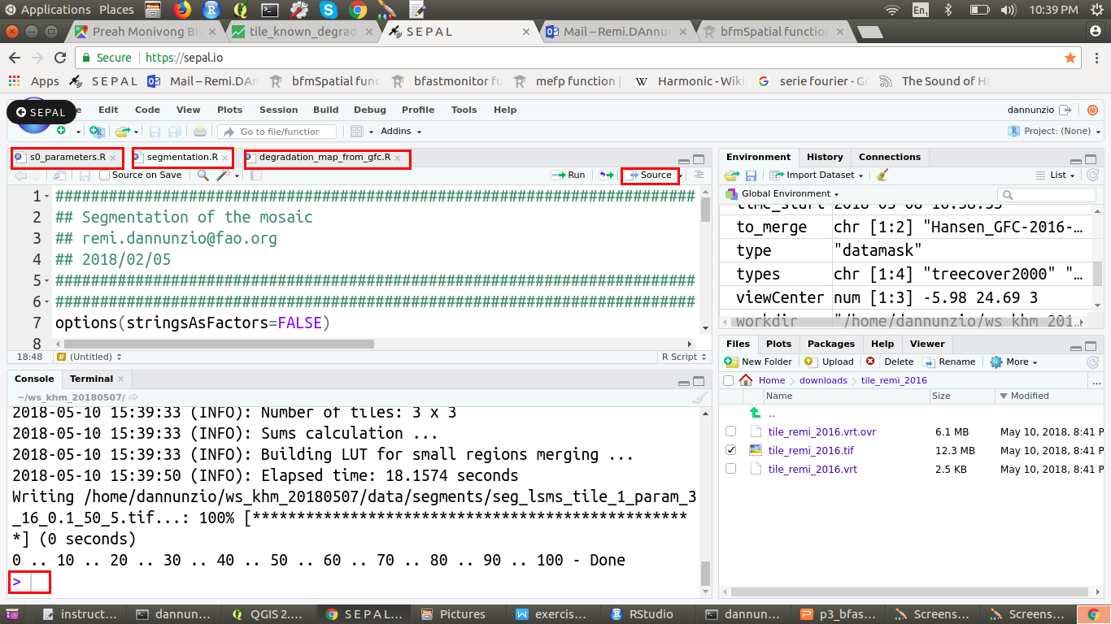

Description of available R scripts

***s0\_parameters.R*** *-> click “source”*

Provide local parameters for your account, load packages and setup the environment variables.

This script should always be run first when you start a new R session.

The first time s0\_parameters.R will run can take a while for the right packages to get installed.

***s1\_convert\_shp\_to\_ceo.R*** *-> run line by line*

Introduction scripts to R for geospatial vector data. This script will read a shapefile of points (location of dams) and output a CSV file with the longitude and latitude of points in a format that can be used as input in CEO.

The result will be under ~/prims/data/data\_canals/xxxx/dams.csv

Download the product to your computer using either Browse or a SSH/FTP solution like FileZilla (go to Files/Site Manager and connect)

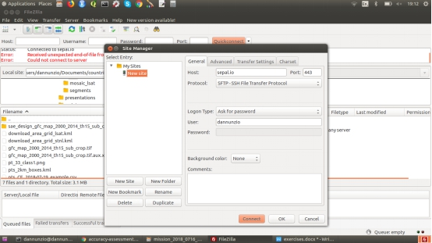

HOST: sepal.io

PROTOCOL: SFTP-SSH File Transfer Protocol

PORT: 443

LOGON: Ask for password

User: your\_sepal\_username

The tutorial for creating and customizing your project in CEO is available here

<http://collect.earth/downloads/CEO_Manual.pdf>

***s2\_get\_data\_create\_tiling\_system.R***

Get administrative layers from [www.gadm.org](http://www.gadm.org), read an area of interest, write vector data (SHP and KML), select features by location and attributes, query DBF files, generate a systematic tiling grid over your AOI for further tiled processing.